

LAB REPORT

VIVA 2

REPRESENT BY:

NEWBIE MEMERS

| Name | Matric Number |
| --- | --- |
| TITUS TAN YU FAN | 23004883 |
| WONG HOONG LIANG | 23053016 |
| SIM JING JIA | 23004919 |
| LIM HONG YU | 23004973 |
| SOON MING HONG | 23004950 |

Question 1

Problem description:

To check if the user’s input is a valid password or not by using java method.

Solution:

import java.util.Scanner;

public class Q1 {

public static void main(String[] args) {

Scanner sc = new Scanner(System.in);

System.out.print("Enter a password to check its validity : ");

String input = sc.nextLine();

if (passwordChecker(input)) {

System.out.println("True");

} else {

System.out.println("False");

}

sc.close();

}

private static boolean passwordChecker(String pw) {

boolean length = false,

CapNSmall = false,

threeDigit = false,

oneSChar = false;

int Cap = 0, smallCaps = 0;

int digitCounter = 0;

int SCharCounter = 0;

if (pw.length() >= 8) {

length = true;

}

for (int i = 0; i < pw.length(); i++) {

if (CapNSmall == false) {

if (Character.isUpperCase(pw.charAt(i))) {

Cap++;

} else if (Character.isLowerCase(pw.charAt(i))) {

smallCaps++;

}

if (Cap >= 1 && smallCaps >= 1) {

CapNSmall = true;

}

}

if (pw.charAt(i) >= '0' && pw.charAt(i) <= '9') {

digitCounter++;

if (digitCounter >= 3) {

threeDigit = true;

}

}

if (!Character.isLetterOrDigit(pw.charAt(i))) {

SCharCounter++;

if (SCharCounter == 1) {

oneSChar = true;

}

}

}

boolean validity;

if (length && CapNSmall && threeDigit && oneSChar) {

validity = true;

} else

validity = false;

return validity;

}

}

We use a scanner to read the user input. After that, the java program will run java method on the next line. In the java method, the password will be checked by using if else statement. The password that meets all rules will return true and false otherwise.

Sample Input & Output: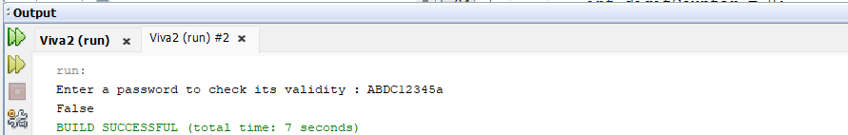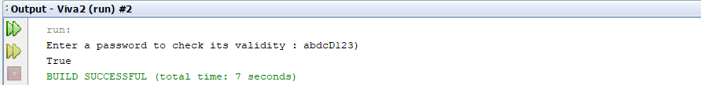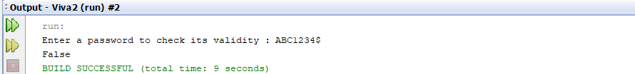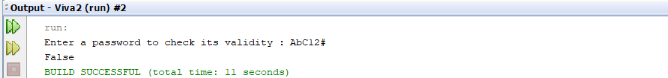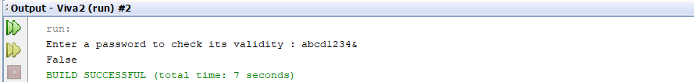

Question 2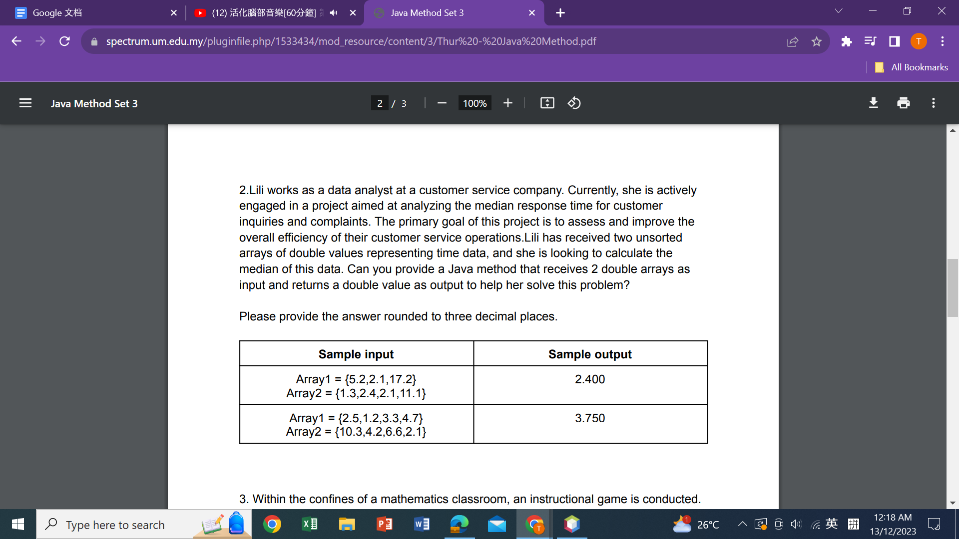

Problem Description:

Receive 2 double array and return a median from the data.

Additional(Receive array.length)

Solution:

import java.util.Scanner;

public class Q2 {

public static void main(String[] args) {

int input1 = *getArraySize*("Enter the number of data to be key in to array 1 : ");

double[] array1 = *getArrayInput*(input1, "Enter the input into array 1: ");

int input2 = *getArraySize*("Enter the number of data to be key in to array 2 : ");

double[] array2 = *getArrayInput*(input2, "Enter the input into array 2: ");

double median = *calculation*(array1, array2);

System.*out*.printf("The median is: %.3f%n", median);

}

private static int getArraySize(String prompt) {

Scanner sc = new Scanner(System.*in*);

int size = 0;

boolean validInput = false;

while (!validInput) {

System.*out*.print(prompt);

if (sc.hasNextInt()) {

size = sc.nextInt();

sc.nextLine(); // Consume the newline character

if (size >= 1 && size <= Integer.*MAX_VALUE*) {

validInput = true;

} else {

System.*out*.println("Please enter a valid input.");//negative int

}

} else {

System.*out*.println("Please enter an integer.");

sc.nextLine(); // Consume the invalid input

}

}

return size;

}

private static double[] getArrayInput(int size, String prompt) {

Scanner sc = new Scanner(System.*in*);

double[] array = new double[size];

for (int i = 0; i < size; i++) {

boolean validInput = false;

while (!validInput) {

System.*out*.print(prompt);

String input = sc.nextLine();

if (!input.isEmpty()) {

try {

array[i] = Double.*parseDouble*(input);

validInput = true;

} catch (NumberFormatException e) {

System.*out*.println("Invalid input. Please enter a valid double.");

}

} else {

System.*out*.println("Please do not leave it blank");

}

}

}

return array;

}

private static double calculation(double[] array1, double[] array2) {

double[] FArray = new double[array1.length + array2.length];

System.*arraycopy*(array1, 0, FArray, 0, array1.length);

System.*arraycopy*(array2, 0, FArray, array1.length, array2.length);

for (int j = 0; j < FArray.length - 1; j++) {

for (int i = 0; i < FArray.length - j - 1; i++) {

if (FArray[i] > FArray[i + 1]) {

double temp = FArray[i];

FArray[i] = FArray[i + 1];

FArray[i + 1] = temp;

}

}

}

int num = FArray.length;

double median;

if (num % 2 == 0) {

median = (FArray[(num / 2) - 1] + FArray[(num / 2)]) / 2;

} else {

median = FArray[(num-1)/2];

}

return median;

}

}

The method getArraySize(String prompt)

is used to read the array1.length and array2.length, if the user enters a non-integer .

System will prompt the user until get the positive integer.

The method getArrayInput((int size, String prompt)

is used to input all elements which is size in array1 and array2 , if the user enters a non-double number. System will prompt the user until get the double number.

The median is caclulate by using method calculation(double[] array1, double[] array2) This method uses arraycopy to copy the array1 and array2 to FArray

Then we use bubble sort to sort the FArray elements in ascending order.To find the median we use the sum of {n/2} term and {n/2 +1} term for even number and {(n+1)/2} term for odd number

In Java we need to -1 to both as the index start with 0.

so the method gets and return median.

In main method it will call the method and display the median in 3 decimal.

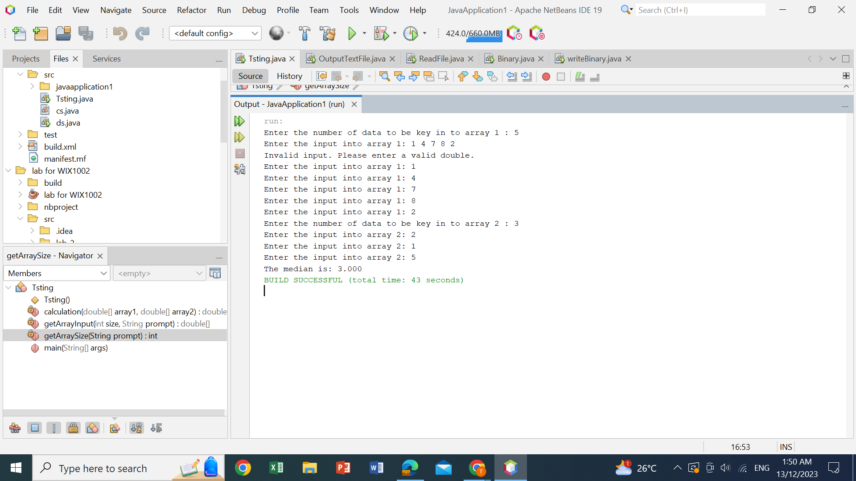

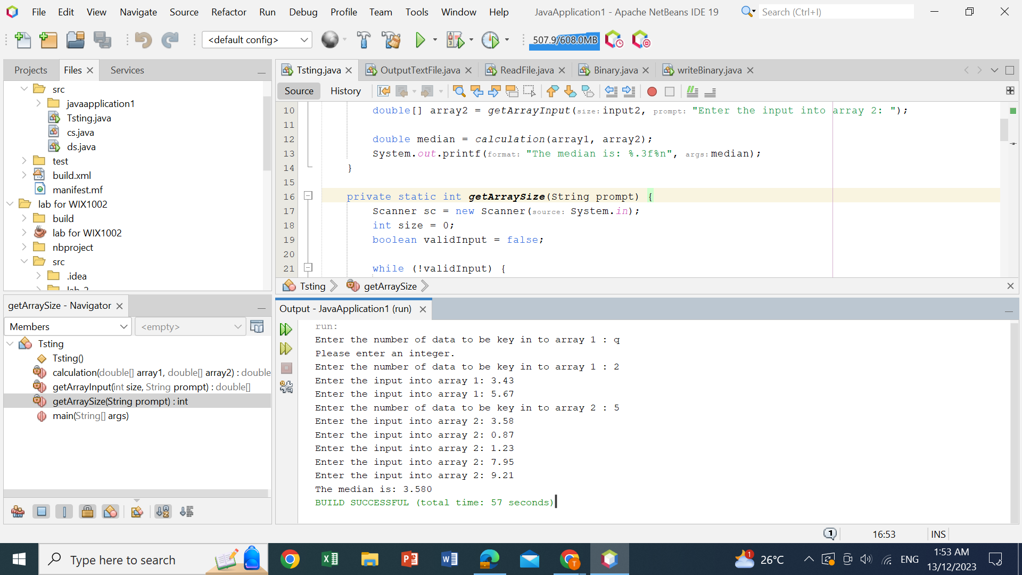

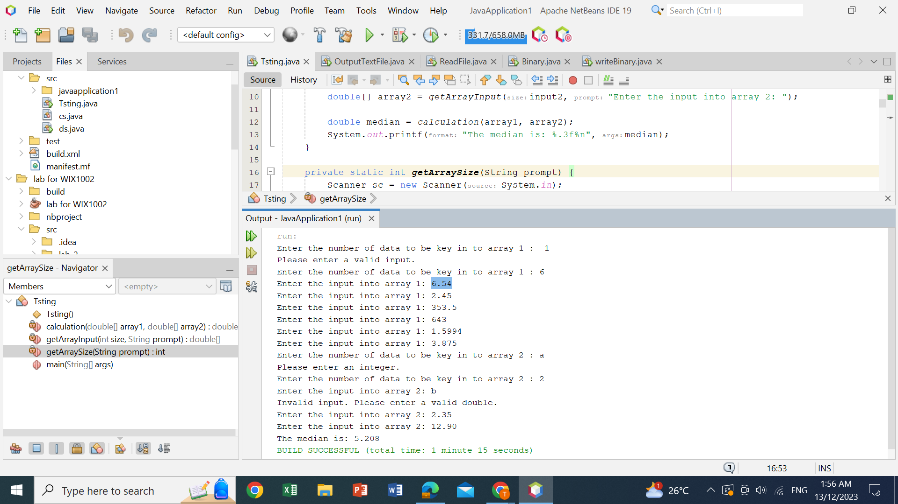

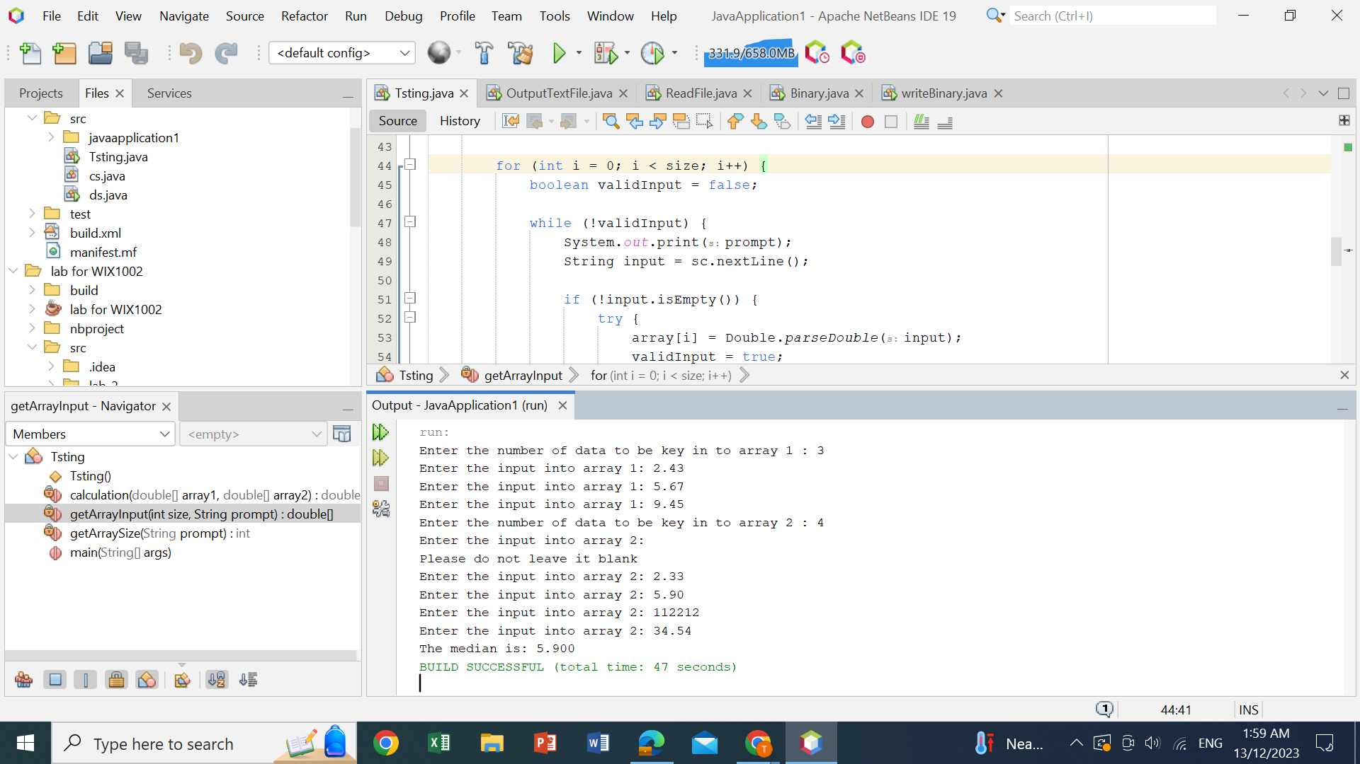

Question 3

Problem description:

To check the validity of the numerical numbers using a Java method that accepts a String array and returns a Boolean array.

Solution:

We use a scanner and an array to accept the input as a String. Next, we use a method to check the numerical validity of each element in the array. To check the numerical validity of each element in the array, we use another method that will try to convert the String into a Double. If the conversion is successful, it is returned as true, whereas if the conversion is not successful, it is returned as false. After checking the validity of each element in the array, we print out the results.

Sample Input & Output:  
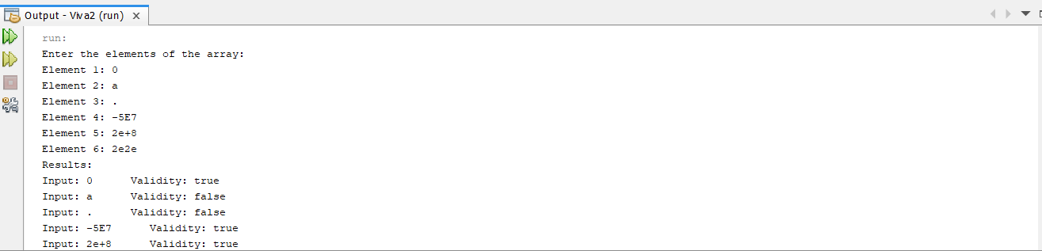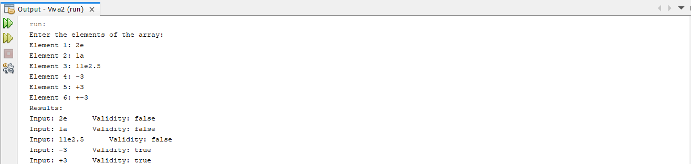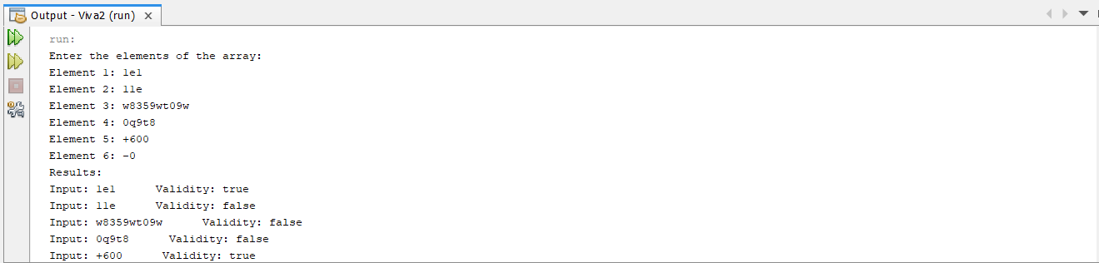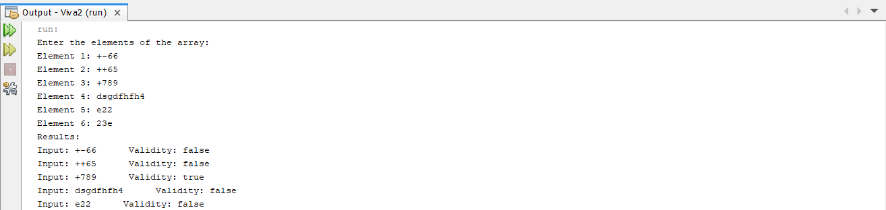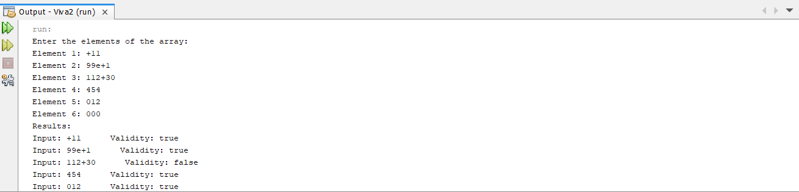

Source code:

